Movies Recommendation

System

Team B

Divya Muppa

Vishnu Gajendran

Manogna Puchhalapalli

Navyatha Bondugula

Bala Krishna Reddy Ramidi

Naga Venkata Aditya Vutukuri

Table of Contents

Installation Steps #InstallationSteps
Run the Backend Drools Engine #RunDroolsEngine
Deploy the war File #DeployWar
Deployment of Database #DeployDatabase
Run the Junit Testcases #JunitTestCases
PROJECT DRIVERS #ProjectDrivers

Purpose of the Product #Purpose

Client, Customers and other Stakeholders #ClientCustomersStakeholders

Users of the Product #UsersOfTheProduct

PROJECT CONSTRAINTS #ProjectConstraints

Mandated Constraints #MandatedConstraints

Relevant Facts and Assumptions #RelevantFacts

FUNCTIONAL REQUIREMENTS #FunctionalRequirements

Scope of Work #ScopeOfWork

Scope of Product #ScopeOfProject

Functional Requirements #FunctionalRequirements
Business UseCase Scenario #BusinessUseCase
RULES #Rules

NON FUNCTIONAL REQUIREMENTS #NonFunctionalRequirements

Usability #Usability

Performance #Performance

Legal #Legal

Security #Security

Maintainability #Maintainability

PROJECT ISSUES #ProjectIssues

Open Issues #OpenIssues

Off-the-Shelf Solutions #OffTheShelf

New Problems #NewProblems

Tasks #Tasks

Cutover #Cutover

Risks #Risks

Costs #Costs

User Documentation and Training #UserDocumentation

Waiting Room #WaitingRoom

Ideas for Solutions #IdeasForSolutions
Architectural System Design #ArchitectureDiagram
Class Diagram #ClassDiagram
Object Diagram #ObjectDiagram
Sequence Diagram #SequenceDiagram
Database Schema #DatabaseSchema
Traceability Matrix #TraceabilityMatrix

Installation and Deployment Documentation
Installation Steps:
- Install Java - http://www.java.com/en/download/help/download_options.xml
- Install Tomcat 7.0 - http://tomcat.apache.org/tomcat-7.0-doc/appdev/installation.html
- Install MySQL - http://dev.mysql.com/doc/refman/5.5/en/installing.html
- Install MySQL Work Bench - http://dev.mysql.com/downloads/workbench/5.2.html
- Install MongoExplorer - http://mongoexplorer.com/
- Make sure we have these files
  - WEBAPP – WAR MovieRecommendationSystem.war
  - DROOLS – JAR DroolsMovieRecommendation.jar
  - JUNIT TestCases- JAR testcase.jar
Run the backend Drools Engine
- This is used to run the time based rules and not action based
- DroolsMovieRecommendation.jar is the executable file which runs on frequent basis to update the database.
- The command to execute
  - cd <path of the jar>
  - java -jar DroolsMovieRecommendation.jar (we can run this as a batch process on the system as well)
Deploy the war –webapp :
- Place the war file in the webapps folder of Tomcat Server 7
- Restart the server
- Open the following link in any browser which supports JavaScript http://localhost:8080/MovieRecommendationSystem/
Deployment of Database
- We have launched our databases in the Amazon WebServices for ease of use for developers.
- Both Mongo db and MySQL are installed in the services.
- The credentials of which are given below
  - MySQL
    - Host name: moviedb.cdmw8xr04c9z.us-east-1.rds.amazonaws.com
    - Port: 3306
    - Username: Vishnu
    - Password: root1234
    - Database name: movieDB
  - Mongo DB
We have created 2 NoSQL databases for the application. Below are the credentials to connect to them
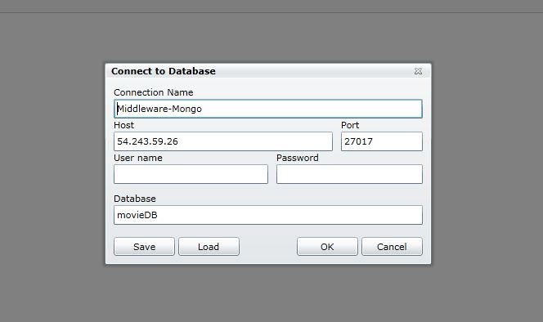

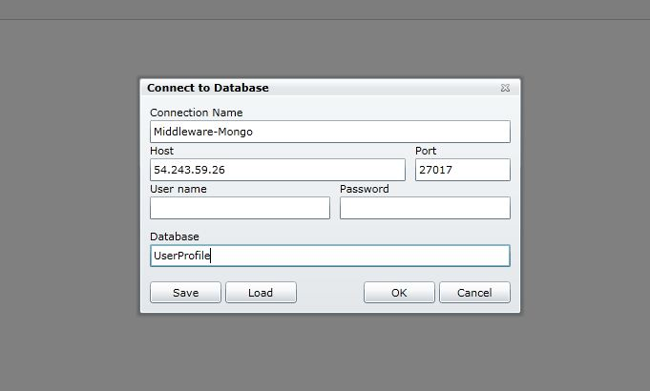

Run the Junit Testcases:
- testcase.jar is the executable file which runs all the test cases for the Application
- The command to execute
  - cd <path of the jar>
  - java -jar testcase.jar
Performance Testing using JMeter:
- Continuous performance testing was done on the web application.
- The installation steps and results are mentioned in attached JMeter_Documentation.doc

PROJECT DRIVERS

Purpose:

The purpose of this system is to recommend movies based on user’s interest. Users can specify their interest by providing specific language, genre, location etc., as input and the system in response will provide the user with list of movies matching his/her interest. User can also view details about movies like ratings and reviews, online sources for viewing the movies etc.

Client, Customers and other Stakeholders

Client : All movie lovers

Customers : The customers for this product are movie lovers and movie critics

Stakeholders : The Stakeholders for this product are Developers, Testers, Marketing agents, third

party license for APIs and tools that we use in developing this product

Users of the Product:

- People who want to search movies that match their interest

- People who want to check ratings and reviews of a particular movie

- Critics who wants to write review and rate movies

PROJECT CONSTRAINTS:

Mandated Constraints

- Solution constraints

  - The product should be developed on Java using Hibernate, Drools,, JDBC

  - Web interface is developed using JSP

  - The application should use distributed systems and execute rules to modify and analyze data across all the systems

  - The application should make use of SQL, NoSQL databases and should make calls to public web service APIs available

- Current Hardware constraints

  - The application should have about 2GB of Relational data

  - The system should contain minimum P4 processor and 2GB RAM
- Scheduling constraints

  - The product should be available for delivery by December 9th, 2012

- Partner Applications

  - We are using MySQL for relational database and MongoDB for non-relational database

  - The system retrieves the movie data from Netflix ,IMDB sites using their APIs

- Budget constraints

  - The system that is being developed must be within the limited budget of the client

Naming Conventions and Definitions:

- MRS - Movie Recommendation System

- API - Application Program Interface

- IMDB - Internet Movie Database

Relevant Facts and Assumptions:

- The user should have internet connection

- The user should have knowledge of movies

- The user should have basic knowledge of using computer

- Netflix and IMDB provide near-accurate data about movies

FUNCTIONAL REQUIREMENTS:

Scope of Work:

This work is useful for people who search for movies relevant to their taste. Designing such a system involves collecting information from users that will aptly record user’s interest on movies. Feedback from users is recorded in terms of reviews and ratings to improve the recommendation system.

Context Diagram :

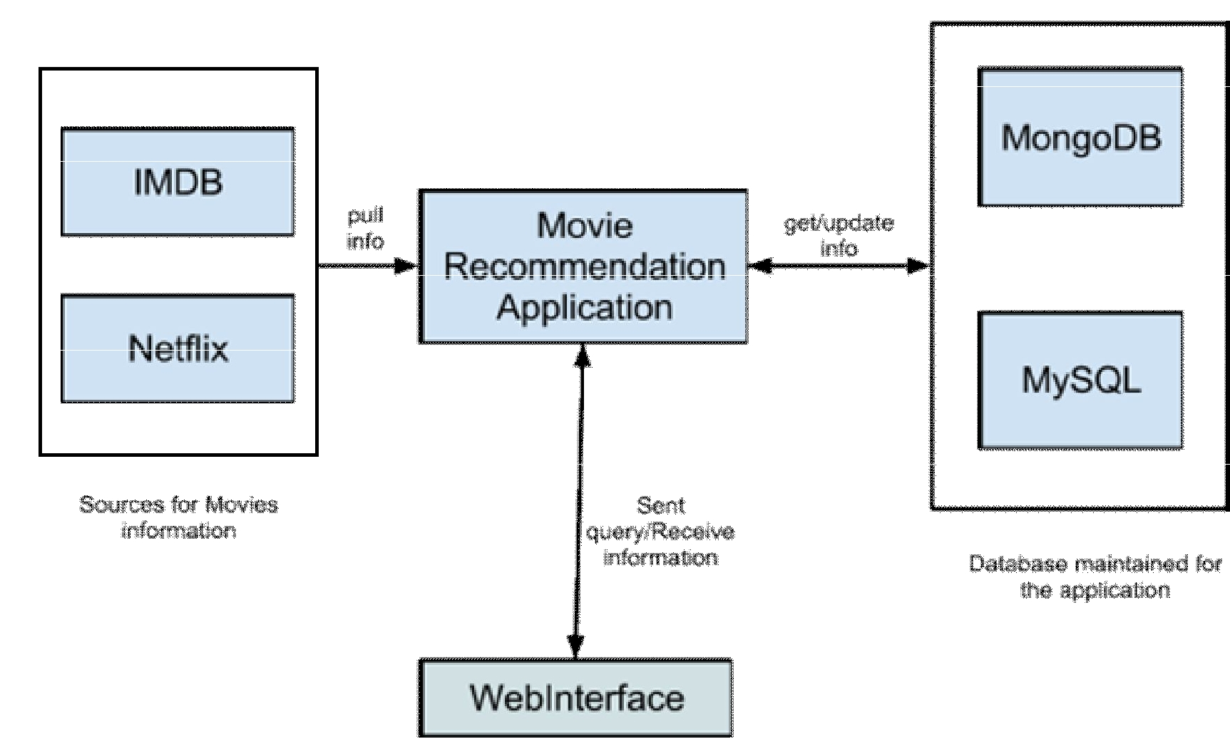

Scope of the Project :

This product implements a system which records user’s like/dislikes (in terms of ratings/reviews) on movies and recommends movies to other users of similar interest. It also lists information about movies which are available in database. Most of information of movies are pulled on a regular basis from sources like IMDB and Netflix.

Business use case list:

Event Name | Input / Output
Users Choice | Application through GUI (i)
MRS program | Updates SQL everyday (i)
MRS Triggers Rules | Input to 3 Databases (i)

Business use case scenario: 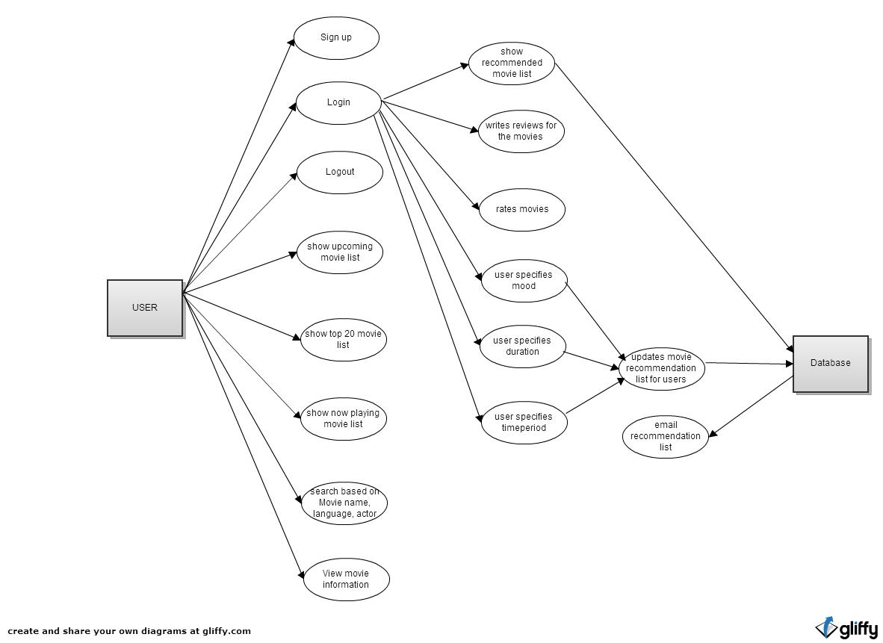

USECASE TABLES:

Functionality: Search movies based on movie name, language, actor

Description | User can search our database based on Movie name, Actor, Language. Our database is being updated in regular intervals of time
Assumptions | User needs to know some information about movies with which he/she can
 | search
Primary Actors | Customers
Secondary Actors | Movie Recommendation System
Preconditions | Data about movies are available in database that we maintain for this
 | application
Postconditions | None
Input | Search parameter (like name, language, actor)
Output | System will output the desired list
Functionality: View movie information like casts, genre, director, writer, reviews and ratings, online streaming sources.

Description |  | View specific details about movies like actor, director, genre, reviews etc.,
Assumptions |  | Information about the movie is available in database
Primary Actors |  | Customers
Secondary Actors |  | Movie Recommendation System
Preconditions |  | Information about that movie is available
Postconditions |  | None
Input |  | Click on the movie link
Output |  | Information about the movie
Functionality: Signup for a new account
Description |  |  | User can open a new account in the system
Assumptions |  |  | User has an emailID to signup for an account
Primary Actors |  |  | Customers
Secondary Actors |  |  | Movie Recommendation System
Preconditions |  |  | No other user has signed up for an account with the same emailID
Postconditions |  |  | None
Input |  |  | emailID, password and other details of the user
Output |  |  | Successfully registered

Functionality: Login to an account
Description |  | User can login to the system using emailID and password
Assumptions |  | None
Primary Actors |  | Customers
Secondary Actors |  | Movie Recommendation System
Preconditions |  | User has already signed up for an account
Postconditions |  | None
Input |  | emailID and password
Output |  | None
Functionality: Logout

Description | Logsout the user from the system
Assumptions | User has an account
Primary Actors | Customers
Secondary Actors | Movie Recommendation System
Preconditions | User is already logged into the account
Postconditions | Recommendation list is no more shown to the user
Input | Click on logout
Output | Redirects to home page
Functionality: Recommend movies when user logins in.

Description | Once the user logged in, recommendation system will recommend the movies
 | automatically based on his profile.
Assumptions | Users profile is complete
Primary Actors | Customers
Secondary | Movie Recommendation System
Actors
Preconditions | User has logged in
Postconditions | User can view the movie recommendation on his screen
Input | emailID and password
Output | List of movies for the user

Functionality: Write movie reviews

Description | User can write reviews about any movies
Assumptions | User has seen the movie and information is correct!
Primary Actors | Customers
Secondary Actors | Movie Recommendation System
Preconditions | User should be logged into the account. Information about the movie is available in database
Postconditions | None
Input | review about the movie
Output | None
Functionality: Rate movies
Description |  | User can rate movies in 1 to 5 (5 is excellent)
Assumptions |  | User has seen the movie!
Primary Actors |  | Customers
Secondary Actors |  | Movie Recommendation System
Preconditions |  | Information about the movie is available in database.
 |  | User is logged in.
Postconditions |  | None
Input |  | Rating for the movie
Output |  | None

Functionality: Show top 20 movies

Description | Based on the data information we have, we show the top 20
 | movies.
Assumptions | Data is accurate. Users like displayed list
Primary Actors | Customers
Secondary | Movie Recommendation System
Actors
Preconditions | Information about the movies is available in database.
Postconditions | N/A
Input | Information from database
Output | Displays Top 20 movie list

Functionality: Show now playing movies

Description | Based on the data information we have, we show the movies
 | that are currently being played.
Assumptions | Data is accurate.
Primary Actors | Customers
Secondary | Movie Recommendation System
Actors
Preconditions | Information about the movie is available in database.
Postconditions | N/A
Input | Information from database
Output | Displays now playing movies

Functionality: Show upcoming movies

Description | Based on the data information we have, we show the movies
 | that are to be released soon.
Assumptions | Data is accurate. Users like to keep themselves updated.
Primary Actors | Customers
Secondary | Movie Recommendation System
Actors
Preconditions | Information about the movie is available in database.
Postconditions | N/A
Input | Information from database
Output | Displays upcoming movies

Functionality: Updates Movie Recommendation list based on mood

Description | Based on the user’s mood, the movie recommendation list is updated
Assumptions | Data is accurate. Users like to keep themselves updated.
Primary Actors | Customers
Secondary | Movie Recommendation System
Actors
Preconditions | Information about the movie mood is available in database.
Postconditions | N/A
Input | Specifies the mood of the user
Output | Updates recommendation list based on the user’s mood
Functionality: Updates Movie Recommendation list based on movie duration

Description | Based on the movie duration specified by the user, the recommendation list is updated
Assumptions | Data is accurate. Users like to keep themselves updated.
Primary Actors | Customers
Secondary | Movie Recommendation System
Actors
Preconditions | Information about the movie duration is available in database.
Postconditions | N/A
Input | User should specify the desired movie duration
Output | Displays upcoming movies

Functionality: Updates Movie Recommendation list based on time period (eg: latest movies, 20’s, 30’s)

Description | Based on the time period specified by the user, the recommendation list gets updated
Assumptions | Data is accurate. Users like to keep themselves updated.
Primary Actors | Customers
Secondary | Movie Recommendation System
Actors
Preconditions | Information about the time period is available in database.
Postconditions | N/A
Input | User specifies the desired time period
Output | Updates movie recommendation list

Functionality: Email recommended movie list to users

Description | The recommendation list is emailed to the user in periodic intervals of time
Assumptions | Data is accurate. Users like to keep themselves updated.
Primary Actors | Customers
Secondary | Movie Recommendation System
Actors
Preconditions | Information about the user’s email ID is available in database.
Postconditions | N/A
Input | None
Output | User receives an email about the recommended movie list

RULES:

This section describes the rules that will be fired based on some events. When a rule is fired, many sub-rules will be fired
- Rule 1: To generate and update the upcoming movie list
- Rule 2: To generate and update the now playing list
- Rule 3: To generate and update the entire movie list
- Rule 4: To generate the recommended movie list for the user based on his previous browsing history
- Rule 5: To send an email alert about the recommended movie list
- Rule 6: When user rates a movie, movie average rating is updated in mongodb
- Rule 7: When user review a movie, movie review is updated in mongodb
- Rule 8: Display 10 movies that start with the same letter as the person’s last name
- Rule 9: To add recommended movies for the users less than 15 years
- Rule 10: To add recommended movies for the users in the range15-25 years
- Rule 11: To add recommended movies for the users in the range 25-35 years
- Rule 12: To add recommended movies for the users in the range 35-45 years
- Rule 13: To add recommended movies for the users in the range 45-55 years
- Rule 14: To add recommended movies for the users greater than 55 years
- Rule 15: To add recommended movies for Male users
- Rule 16: To add recommended movies for Female users
- Rule 17: To add recommended movies for users with language preference as English
- Rule 18: To add recommended movies for users with language preference as French
- Rule 19: To add recommended movies for users with language preference as Hindi
- Rule 20: To add recommended movies for users with language preference as Mandarin
- Rule 21: To add recommended movies for users with language preference as German
- Rule 22: To add recommended movies for the users in US location
- Rule 23: To add recommended movies for the users in Europe location
- Rule 24: To add recommended movies for the users in France location
- Rule 25: To add recommended movies for the users in Asia location
- Rule 26: To add recommended movies for the users in Africa location
- Rule 27: To add recommended movies for the users with genre preference as Action
- Rule 28: To add recommended movies for the users with genre preference as Mystery
- Rule 29: To add recommended movies for the users with genre preference as Romance
- Rule 30: To add recommended movies for the users with genre preference as Drama
- Rule 31: To add recommended movies for the users with genre preference as Documentary
- Rule 32: To add recommended movies for the users with genre preference as Animations
- Rule 33: To add recommended movies with 1 hour duration
- Rule 34: To add recommended movies with 1 hour 30 minutes duration
- Rule 35: To add recommended movies with 2 hour duration
- Rule 36: To add recommended movies with 2 hour 30 minutes duration
- Rule 37: To add recommended movies with 3 hour 30 minutes duration
- Rule 38: To add recommended movies related to 90’s time period
- Rule 39: To add recommended movies related to 20’s time period
- Rule 40: To add recommended movies related to 30’s time period
- Rule 41: To add recommended movies related to ancient time period
- Rule 42: To add recommended movies related to middle ages

NON FUNCTIONAL REQUIREMENTS:

Non-functional requirements specify the qualities that a system must possess. It is also known as Quality Requirements. Nonfunctional requirements can make or break a product.

1. Usability

A good system should always be easy to use. Usability is the ease at which the user uses the product. The Usability requirements for a Movie Recommendation System are

  - The system should be easy to understand

  - Eighty percent of the users will prefer to use the product after a one week familiarization period

  - The system must provide a faster approach for accessing and managing of search criteria The system should use a simple interface to present the movie recommendation system

  - The system should have an option to refer to documentation for help

- Performance

Reliability:

● The system ensures that consistency of data is maintained while working with multiple

transactions

- If the system crashes during the transaction, then the recovery procedures which are present will make sure that the transaction resumes after system restarts

- The product will be available throughout the year

Time:

- Response time- The load time for the main screen should no longer take more than 15 seconds

- Throughput time- The results of analysis should be displayed in less than 60 seconds

Space:

- We should make sure that redundancy and inconsistency is avoided and data is stored in a safe place

- The system should require 5GB of free disk space

Operational

- The system should be supported by any Operating system that has Java installed on it

- The system needs Internet connectivity
  - The system should update its central database everyday using web service

  - The system can support multiple users

  - It should use MySQL and Mongo database to store and manage the data

  - It should be flexible to adapt to the upgraded versions

- Legal

  - The system should use US English only

  - The system should have patent rights

  - The system should be developed and used only in the United States

- Security

Integrity:

  - The system should ensure that the data is same as the source Availability:

  - The system should ensure that the data is available only all users

- Maintainability

  - The system should be easy to be upgraded to future versions without affecting existing functionalities

  - The system would be flexible to adapt to new domain(Books, Music) changes in nearby future

·

PROJECT ISSUES

- Open Issues

  - Selection of attributes for search criteria

  - Meeting the current performance goals given the dependency on third party APIs.

  - Setting the threshold limits to predict the future movies success rate

- Off-the-Shelf Solutions

2a. Is there a ready-made system that could be bought?

● There is no distributed system that can access various open source APIs.

2b. Can ready-made components be used for this project?

  - In addition to the tools and libraries provided with Java, the software will use a MySQL database, Mongo database and web services as data sources. MySQL is provided free and will be used to store some data generated through the use of the application.

  - The application shall use DROOLS framework to execute rules based on user input.

  - The application shall use Hibernate to maintain persistence for the queried data.

3.New Problems

If any of the database servers goes down, it would be difficult to predict the result correctly.

4. Tasks

The system will go through design, implementation, and testing phases before being delivered to the client. Documentation for the system will be delivered after the system is implemented.

The design phase will define the architecture of the system which will be completed in the implementation phase. It is estimated that design will take about two weeks after the requirements document is approved. Implementation is anticipated to take approximately two weeks after the design is complete. Finally, two weeks after implementation the complete documentation for the system will be delivered to the client.

5. Cutover

Cutover risks for this project are minimal. The functionality of the product will be relatively new and there is no current system which will predict the interests like ours. Since it is being retrieved from number of data sources the system is more reliable

5a. What special Requirements do we have to get the existing data and procedures to work for the new system?

All data will be automatically imported from the IMDB, Netflix, Rottentomatoes periodically. 5b. What data has to be modified/translated for the new system?
Data will be updated regularly from the specified databases

6. Risks

The development time could have been inaccurately estimated which may cause the quality of the product to decrease or not all of the requirements could be met.

The prediction might be slow based on the communication time to interact with the web service. Care will have to be taken to make sure the system is easy to use and responsive.

Creeping user requirement: Some keys may not be active for longer periods for web services and hence a high risk of changing the API’s or cutting down some requirements given by it.

- Costs

    - Based upon the number of use cases and requirements we estimate that this product will require at least 6 developers to complete within the given time frame.

    - Also the development time is estimated to be 12 to 15 days for 6 developers contributing several hours per day. This figure was developed based on past experience with projects in similar domains with similar scope.

  - User Documentation and Training

The complete manual for the product shall be delivered. The format of this document will be agreed upon at a later date but will provide a breakdown for each subsystem and a detailed explanation of how to use the system effectively. We provide a help button for the users which has details on web-site flow. No formal training has been included with the project, however representatives will be available to answer any questions or troubleshoot issues following deployment.

- Waiting Room

  - This application can be served as white label product and can be extended to music, books etc

  - The system can communicate with greater number of data sources to cover a greater range of movies and give accurate results

- Ideas for solutions

  - A possible solution for designing the system would be to develop the application as a web based application. The model used for web applications is very similar to the application that needs to be developed for Movie Recommendation System.
- The UI for the system might be easily defined by HTML/JSP and the connectivity to database is made through hibernate. We are using SQL, NOSQL databases and we will be using the web services to get data from public API’s.

- The framework would also provide Model-View-Controller ideology that we feel would be very suitable for this kind of application.

- Using a web application in this manner we can also leverage browser features to improve the overall quality of the product without increasing the timetable. Modern browsers can provide key features for the product, including printing with various print options, in addition to non-critical amenities such as zooming and bookmarking.

- Despite this concern, it would appear that this approach has the potential to significantly decrease development time for the application.

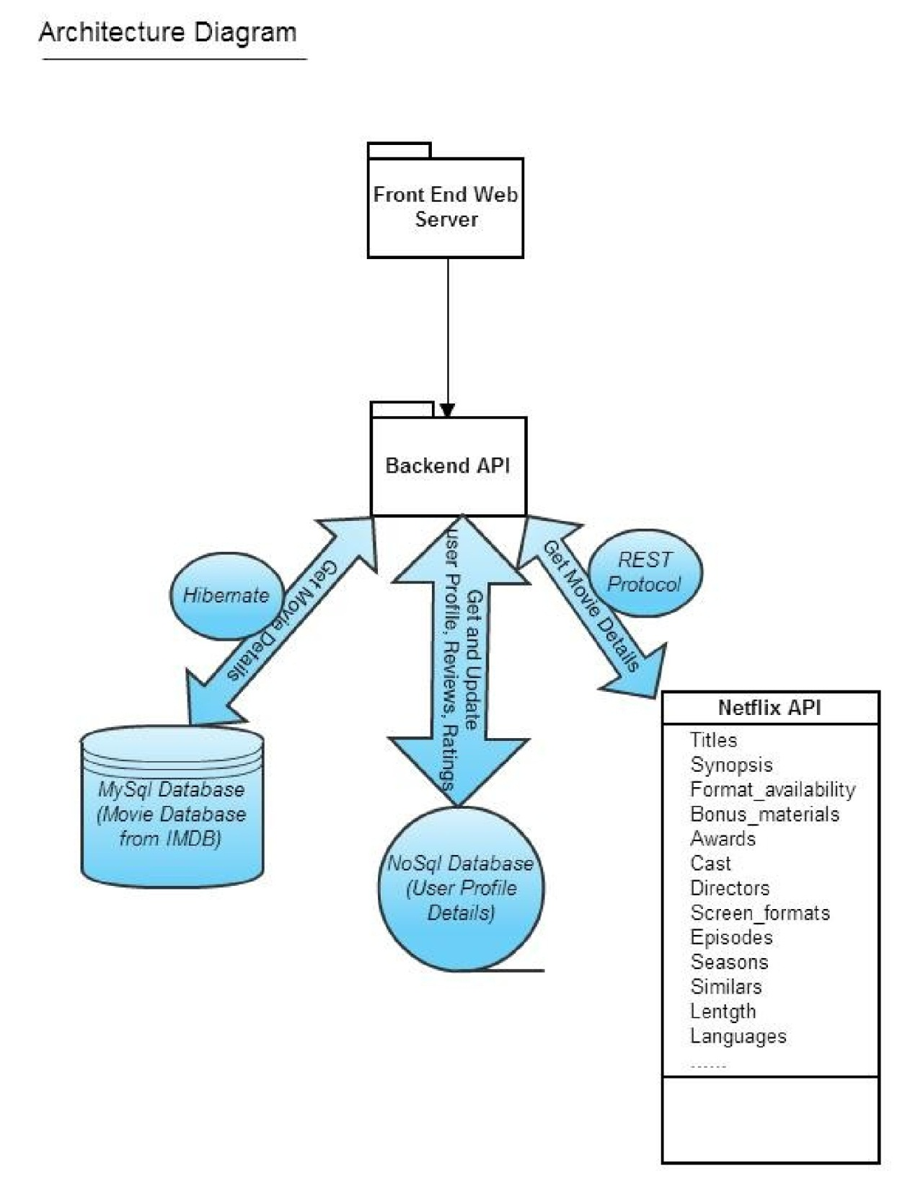
System Architecture Design
Movie recommendation System is implemented across various distributed systems. At high level, the entire system is divided into three components namely,

- Front End Web Server (Tier 1)

- Backend engine (Tier 2)

- Database Systems (Tier 3)

Front End Interface:

The front end web server runs tomcat web service to handle requests from the client connecting to the movie recommendation application. The front end is designed using MVC(Model View Controller) architecture

Backend Engine:

Backend engine is responsible for connecting to the databases and querying the API to get the results. All the rules are executed at the backend. The algorithms to get the recommendations for each user is also run at the backend. The databases are regularly updated from the source.

Database Systems:

- The data in MySql database is populated from IMDB. Algorithms are run at the backend to update this data at regular intervals of time.
- NoSql database holds information related to the user's interest. Each user’s recommended-list is updated automatically based on the users browsing/search history. Since the updates on NoSql database are quicker than MySql, these data is stored on NoSql database.

  - Since movie ratings and reviews also need lot of updates, we store the reviews and updates in NoSQL database.

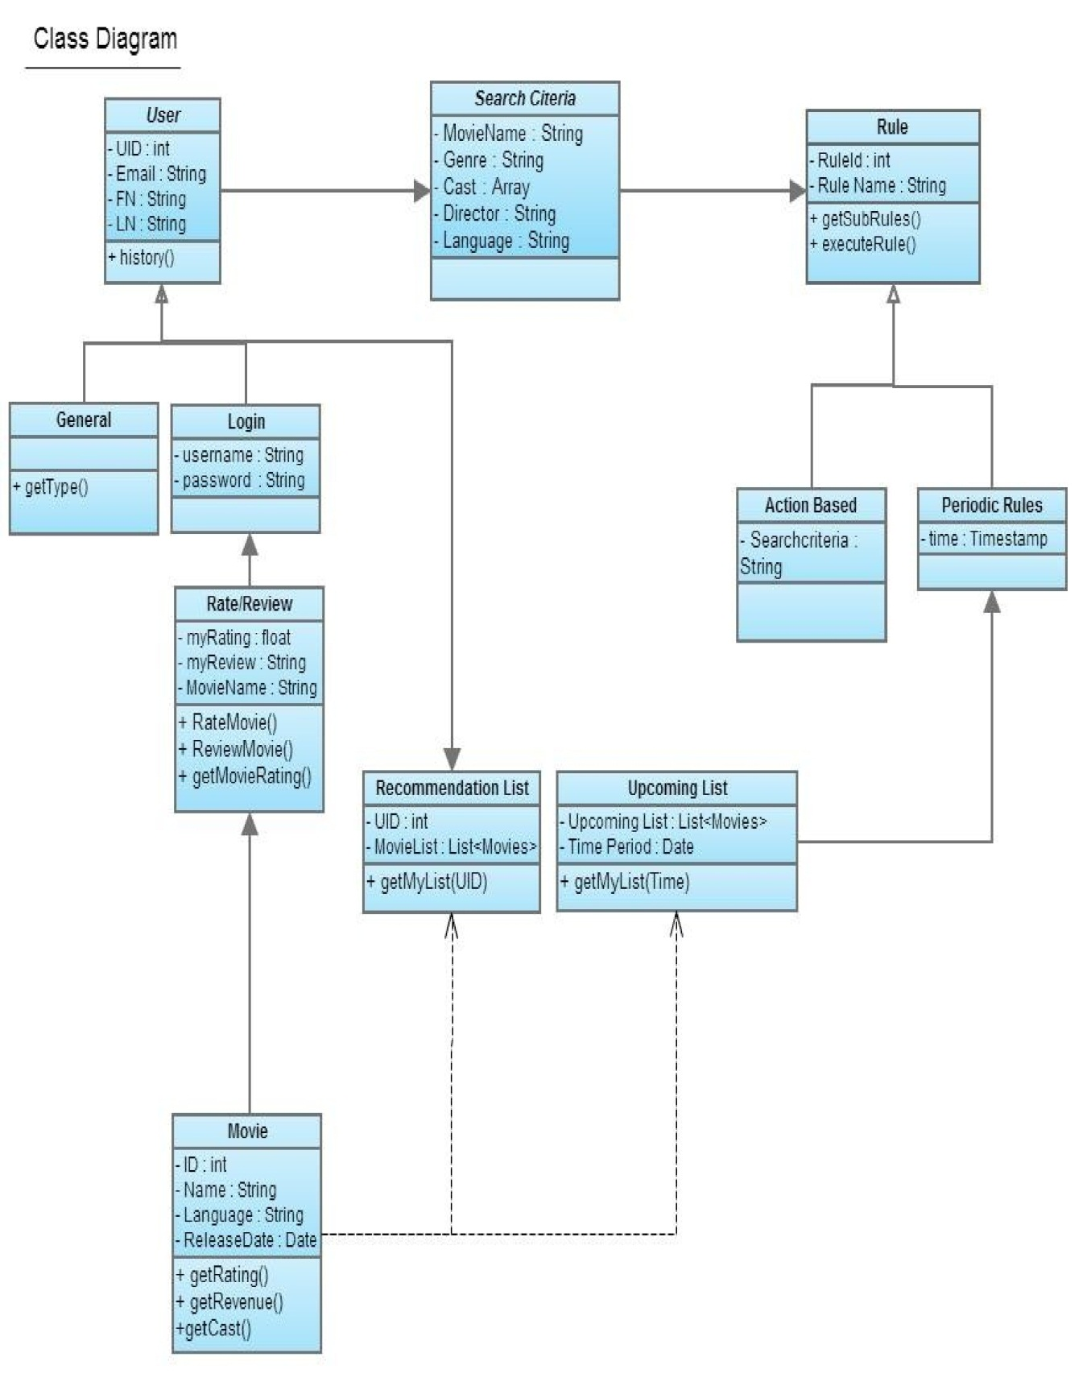
Class Diagram
Description of the Class Diagram :

- The front end of the application has user, that can be two types-general and registered user. The registered user needs to enter username and password.
- The user can search for movies by providing many criteria, some of which are movie name, genre, cast, director, language etc., and rule is triggered accordingly.

- Each User can give multiple search criteria and each criterion can trigger multiple rules.
- Rules are classified into two categories: Periodic and Action based. Periodic rules are run based on the time like - updating the movie list every day at 11:59 PM. Action based rules are invoked on particular event.

- Each rule can call multiple other rules.

- Each user has a list of recommended movies which keeps updated.

- The Upcoming movie list keeps on updating itself. It is the same for all users.

- Movie is the main entity of the MRS application. The Upcoming movie list and the recommended movies entity has list of movies.

Front-end of our application is a web-interface by which user can search movies, login to their account to view recommended movies for them, view upcoming movies, rate or give reviews to movies etc. This section describes the design of this Front-end component of our application

Components in Front-end:

- User login panel

- Search Box with options (for search parameters like actor, director) to search for movies
- List movie information

- Recommended movies for a signed-in user

- List of upcoming movies
- List of now playing movies
- User can specify the mood
- User can specify the duration
- User can specify the time period

Backend of our application is the APIs that we are going to implement. This APIs
can be used by the Front-end web interface to retrieve specific information about movies, users from the database. These APIs will take care of accessing mySQL and

MongoDB databases to retrieve relevant information. These APIs will be designed in a generic way so that it can be used by any application programmer who wants to build some new system based on Movies information. Backend of our application also comprises of Drools rule engine that will fire rules based on time or certain events

Object Diagram:
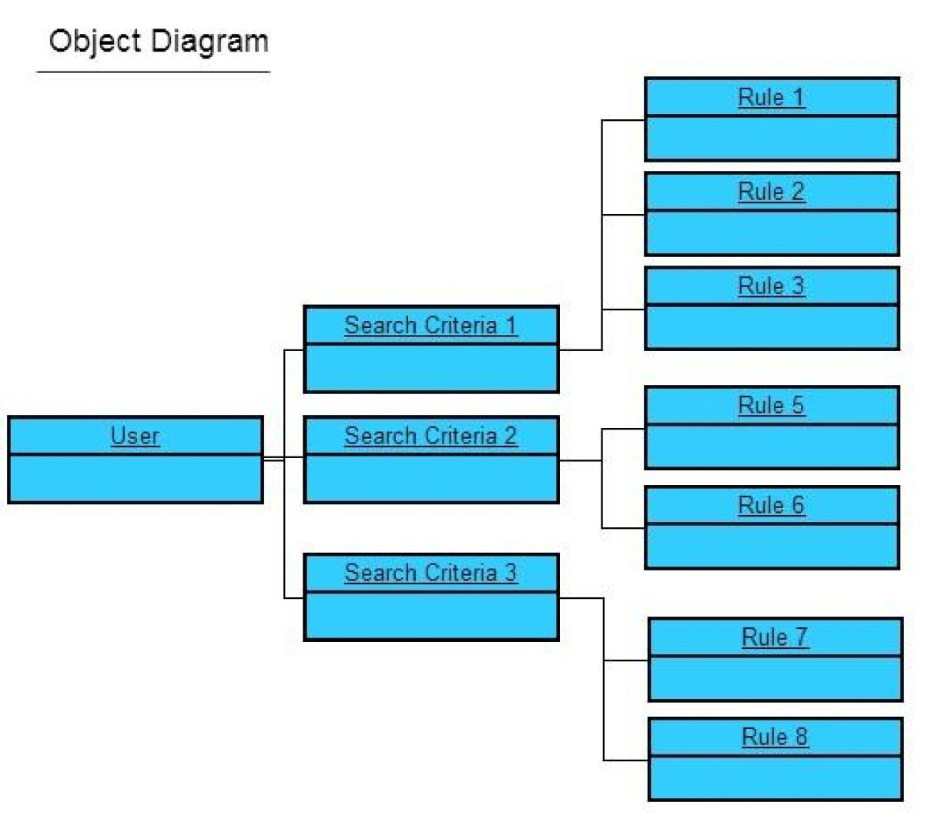

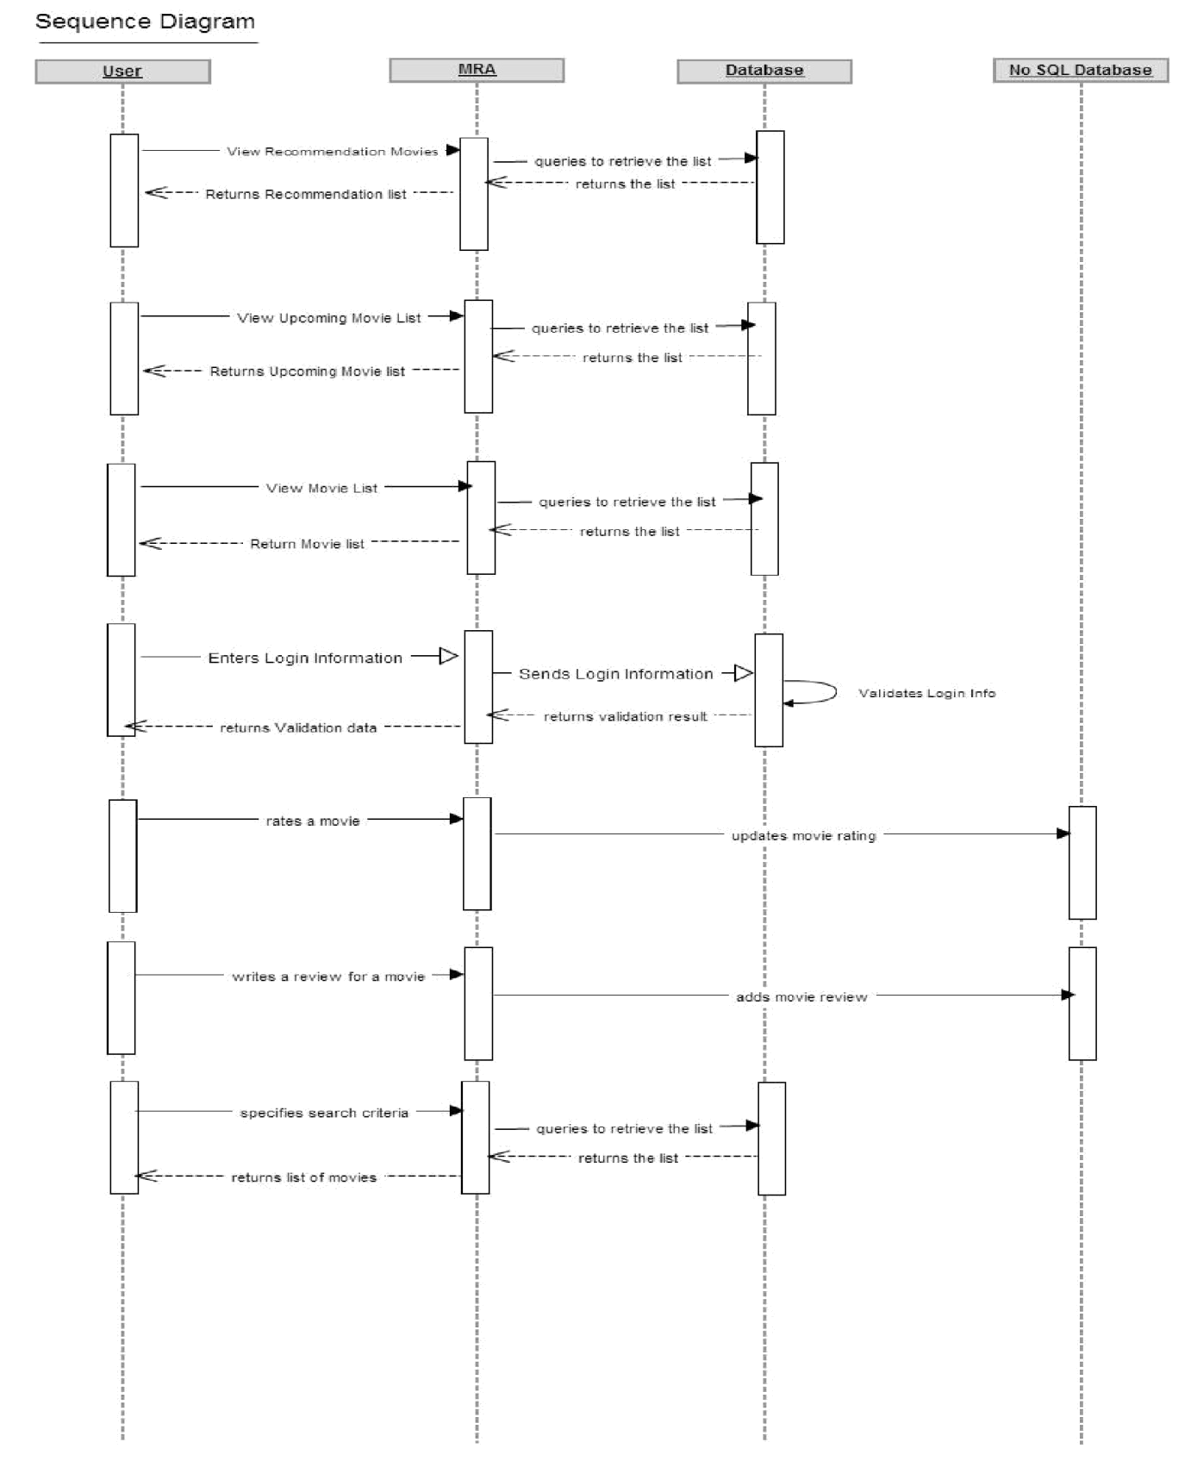

Database Schema:

MySQL: MovieDB database contains the following tables:

actor(aid,fullname,fname,lname,gender)
actor_movies(actors_aid,movies_mid,role,notes,credit_no)
genre(gid,genre)
genre_movies(movies_mid,genres_gid)
language(lid,language,language_notes)
language_movies(movies_mid,languages_lid)
movies(mid,title,year,year_end,vtype,notes,rating,num_votes, distribution,year_suffix)
now_playing_movies(mid,title,year,year_end,vtype,notes,rating, num_votes,distribution,year_suffix)
upcoming_movies(mid,title,year,year_end,vtype,notes,rating, num_votes,distribution,year_suffix)

9

NOSQL:

- UserProfile database contains the following table

- testCollection(passwd, lastName, favMovies, timeperiod, mood, loc, lang, history, duration, email, userId, age, gender, firstName)

- MovieDB database contains the following tables:

- upcomingmovies(id,title,voye_average,backdrop_path,release_date, original_date,vote_count,poster_path)

- upcoming_movie(id,title,voye_average,backdrop_path,release_date, original_date,vote_count,poster_path)

- testcollection(mid,rating) where key is mid and value is rating
- age(age, movie) where key is age and the value is movie name

- gender(gender, movie) where key is gender and the value is movie name

- genre(genre, movie) where key is genre and the value is movie name

- location(location, movie) where key is location and the value is movie name

- language(language, movie) where key is language and the value is movie

- mood(mood,movie)where key is mood and the value is movie name

- Duration(num_of_hours,movie)where key is the length of the movie and the value is movie name

- Period(period,movie)where key is the time period of movie and the value is movie name

Traceability Matrix :

Sl. No. | Functional Requirement | Requirement link | Artifact | Software Module (Package.Class.Method) | Test Case Name | Results
1 | Search movies based on name | #SearchMoviesBasedOnMovieNameLanguageActo | User | mrs.Search.doGet, details.jsp | SearchMoviesTest | Passed
2 | Search movies based on actor | #SearchMoviesBasedOnMovieNameLanguageActo | User | mrs.Search.doGet, details.jsp | SearchActorsTest | Passed
3 | Search movies based on language | #SearchMoviesBasedOnMovieNameLanguageActo | User | mrs.Search.doGet, details.jsp | SearchLanguagesTest | Passed
4 | View Movie Information | #ViewMovieInformation | User | mrs.Search.doGet, mrs.addHistory, movieInfo.jsp | SearchMoviesTest | Passed
5 | Signup for a new account | #Signup | User | mrs.Register.doPost, signup.jsp | RegisterUser | Passed
6 | Login into your account | #Login | User | mrs.Login.doPost, home.jsp | LoginTest, LoginFailure | Passed
7 | Logout from your account | #logout | User | mrs.Logout.doGet, home.jsp | LoginNotPresent | Passed
8 | Recommend movies when user login in | #RecommendMovies | User | mrs.ShowRecommendation.java, recommendation.jsp | testInsertSingleRecommendationSuccess, testInsertSingleRecommendationFailure | Passed
9 | Write movie reviews | #MovieReviews |  | mrs.ReviewRating.doPost, drools.main.DroolsApi, reviewRating.jsp | testReview | Passed
10 | Rate movies | #RateMovies | User | mrs.ReviewRating.doPost, drools.main.DroolsApi, reviewRating.jsp | testRating | Passed
11 | Show top 20 movies | #ShowTop20Movies | User | mrs.TopMoviesTMDBAPI.java, topMovieList.jsp
12 | Show now playing movies | #ShowNowPlayingMovies | User | mrs.NowPlayingMovies.java, nowPlayingMovies.jsp
 | Show upcoming movies | #ShowUpcomingMovies | User | mrs.UpcomingMovies.java, upcomingMovies.jsp
14 | Updates users movie recommendation list based on this mood | #UpdatesMovieListBasedOnMood | User | mrs.SetInterest.java, drools.main.DroolsApi, drools.movieapi.MoviesApi.java | MoodExciting, MoodFeelGood, MoodMindBending, MoodRough, MoodThoughtProvoking, MoodWitty | Passed
15 | Updates users movie recommendation list based on movie duration | #UpdatesMovieListBasedOnDuration | User | mrs.SetInterest.java, drools.main.DroolsApi, drools.movieapi.MoviesApi.java | DurationTest1, DurationTest130, DurationTest2, DurationTest230, DurationTest330 | Passed
16 | Updates users movie recommendation list based on movie time period | #UpdatesMovieListBasedOnTimePeriod | User | mrs.SetInterest.java, drools.main.DroolsApi, drools.movieapi.MoviesApi.java | Period20s, Period30s, Period90s, PeriodAncient, PeriodMiddle | Passed
17 | Email user his movie recommendation list | #EmailRecommendedMovies | Database and User | drools.email.SendMail.java | SendmailTest | Passed
18 | Generate recommendation list for the user based on his profile |  | Database | drools.main.DroolsApi, drools.movieapi.MoviesApi.java | GenreAction, GenreAnimation, GenreDocumentary, GenreDrama, GenreMystery, GenreRomance, | Passed

Testcases for backend rules engine:

LanguageEnglish()
LanguageFrench()
LanguageGerman()
LanguageHindi()
LanguageMandarin()
LocationAfrica()
LocationAsia()
LocationEurope()
LocationFrance()
LocationUS()
GendertFemale()
GendertMale()
AgeTest10()
AgeTest20()
AgeTest30()
AgeTest40()
AgeTest50()
AgeTest60()

